Lab No. 03

STL Sequential Containers: Array & Vector
Task 1 [10]
Declare an STL array of size 500 and populate is with random integers. Write a function even_odd_average to find the average of even and odd numbers separately.
Code:
#include <iostream>
#include <array>
#include <cstdlib>
#include <ctime>
using namespace std;

void even_odd_average(array<int, 500> a)
{
int evenSum = 0, oddSum = 0;
int even = 0, odd = 0;
for (int i = 0; i < 500; i++)
{
if (a[i] % 2 == 0)
{
evenSum = evenSum + a[i];
even++;
}
else
{
oddSum = oddSum + a[i];
odd++;
}
}
cout << "Even average " << evenSum / even << endl;
cout << "Odd average " << oddSum / odd << endl;
}
int main()
{
array<int, 500> a;
srand(time(0));
for (int i = 0; i < 500; i++)
{
a[i] = rand() % 100;
}
even_odd_average(a);
return 0;
}
Output: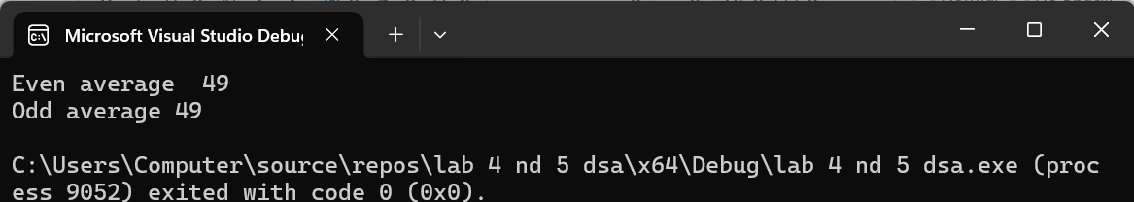

STL Vector in C++
A vector container stores and manages its objects in a dynamic array. Since an array is a random access data structure, so the elements of a vector can be accessed with the help of index. Item insertion in the middle or beginning of an array is time consuming (i.e. O(N) ), especially if the array is large. However, inserting an item at the end is fast (i.e. O(1) ). The name of the class that implements the vector container is vector. (Recall that containers are class templates.) The name of the header file containing the class vector is vector. Thus, to use a vector container in a program, the program must include the following statement:
#include <vector>
Furthermore, to define an object of type vector, we must specify the type of the object because the class vector is a class template. For example, the statement
vector <int> intList; vector<string> stringList;
declares stringList to be a vector container and the component type to be string.
Following is the code to fill a vector with random values.
void rand_num_filler(vector<int> & vec, int range)
{
for(unsigned int i=0; i<vec.size(); i++)
vec[i] = rand() % range; // filling the array with random values
}

Task 2 [5]
Write the definition of the function template reverse_vector to reverse the elements of a vector object.
template <class elemType>
void reverse_vector(vector <elemType> &list);
// Reverses the elements of the vector list.
// Example: Suppose list={4,8,2,5}.
// After a call to this function, list={5,2,8,4}

Code:
#include <iostream>
#include <vector>
using namespace std;

template <class elemType>
void reverse_vector(vector <elemType>& list)
{
int start = 0;
int end = list.size() - 1;
while (start < end)
{
elemType temp = list[start];
list[start] = list[end];
list[end] = temp;

start++;
end--;
}
}
int main()
{
vector<int> list;
list.push_back(4);
list.push_back(8);
list.push_back(2);
list.push_back(5);
reverse_vector(list);
cout << "Reversed vector: ";
for (int i = 0; i < list.size(); i++)
{
cout << list[i] << " ";
}
return 0;
}
Output: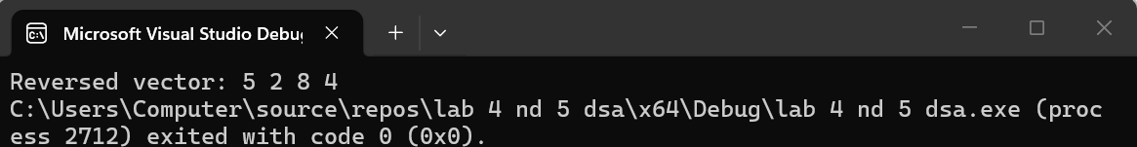

Task 3 [4+4+2=10]
Create an integer type vector of size 500. Populate this vector using filler function. Use this vector for following subtasks.
- Write a function which returns the maximum value and the associated index of the passed vector. Its prototype would like as follows;
int vec_max(vector<int> & vec, int & pos);

- Write a function which adds index position of the passed vector in the existing values of this passed vector.
void vec_seq_num(vector<int> & vec);
- Test these functions by making call to them in a main() function.
Code:
#include <iostream>
#include <vector>
using namespace std;

void fill_vector(vector<int>& vec)
{
for (int i = 0; i < 500; i++)
{
vec.push_back(rand() % 100);
}
}
int vec_max(vector<int>& vec, int& pos)
{
int max = vec[0];
pos = 0;
for (int i = 1; i < vec.size(); i++)
{
if (vec[i] > max)
{
max = vec[i];
pos = i;
}
}
return max;
}
void vec_seq_num(vector<int>& vec)
{
for (int i = 0; i < vec.size(); i++)
{
vec[i] = vec[i] + i;
}
}
int main()
{
vector<int> vec;
int position;
fill_vector(vec);
int maximum = vec_max(vec, position);
cout << "Max value " << maximum << endl;
cout << "Index " << position << endl;
vec_seq_num(vec);
return 0;
}
Output:
Task 4 [5+5+5=15]
Create a vector of integer type of arbitrary size and populate it using following filler function.
Part A
Create a function split_vector() which takes above vector as input and split this vector into two vectors, i.e.v1 & v2, in such a way that v1 contains all even numbers & v2 contains all odd numbers and return both vectors back to caller function.
Code:
#include <iostream>
#include <vector>
using namespace std;

void split_vector(vector<int>& vec, vector<int>& v1, vector<int>& v2)
{
for (int i = 0; i < vec.size(); i++)
{
if (vec[i] % 2 == 0)
{
v1.push_back(vec[i]);
}
else
{
v2.push_back(vec[i]);
}
}
Part B
Write another function which takes a vector and remove all duplicate numbers.
Code:
void remove_duplicates(vector<int>& vec)
{
for (int i = 0; i < vec.size(); i++)
{
for (int j = i + 1; j < vec.size(); j++)
{
if (vec[i] == vec[j])
{
vec.erase(vec.begin() + j);
j--;
}
}
}
}void remove_duplicates(vector<int>& vec)
{
for (int i = 0; i < vec.size(); i++)
{
for (int j = i + 1; j < vec.size(); j++)
{
if (vec[i] == vec[j])
{
vec.erase(vec.begin() + j);
j--;
}
}
}
}
Part C
Now calculate sum of elements of each vector (i.e. v1 & v2), after removing all duplicate elements from vectors, using function sum which you have created in Lab 1.
Code:
int main()
{
vector<int> vec = { 2, 4, 2, 5, 3, 4, 5 };
vector<int> v1, v2;
split_vector(vec, v1, v2);
cout << "Sum of v1 " << sum_after_cleanup(v1) << endl;
cout << "Sum of v2 " << sum_after_cleanup(v2) << endl;
return 0;
}
Output: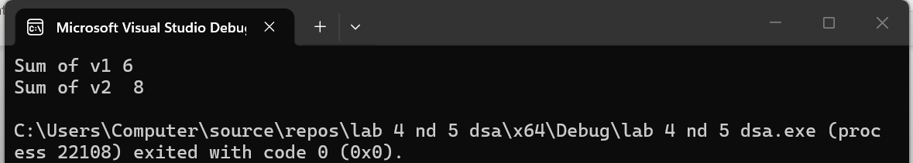
Task 5 [2+3+3+2=10]
Say we are writing the next version of a nifty new mail reading program and want to use a Vector (interface in reader appendix) to store all the data. The following structure is used to hold the data of an email message:
struct eMailMsg {
string to; // i.e. "professor@abasyn.edu.pk"
string from; // i.e. "student@@abasyn.edu.pk "
string message; // body of message
string subject; // i.e. "CS210 Rocks!"
int date; // date email was sent
int time; // time email was sent
};
a) How would you declare a Vector that stores eMailMsgs?
b) Write a function RemoveSpam that takes a vector containing elements of type eMailMsg and removes all elements whose subject begins with the string "SPAM".
c) How could you modify the field of the eMailMsg structure so that it can hold the email addresses of an arbitrary number of recipients of an email? With the modification in place, given an eMailMsg email, how would you access the last address listed in the field?
Code:
#include <iostream>
#include <vector>
#include <string>
using namespace std;

struct eMailMsg {
vector<string> to;
string from;
string message;
string subject;
int date;
int time;
};
void RemoveSpam(vector<eMailMsg>& emails)
{
for (int i = 0; i < emails.size(); i++)
{
if (emails[i].subject.substr(0, 4) == "SPAM")
{
emails.erase(emails.begin() + i);
i--;
}
}
}
int main()
{
vector<eMailMsg> emails;
eMailMsg e1;
e1.to = { "professor@abasynedu.pk", "ta@abasyn.edu.pk" };
e1.from = "student@abasyn.edu.pk";
e1.subject = "CS210 DSA!";
e1.message = "Hello Sir";
e1.date = 6;
e1.time = 1000;

eMailMsg e2;
e2.to = { "sajal@abasyn.edu.pk" };
e2.from = "spam@unknown.com";
e2.subject = "SPAM Buy now!";
e2.message = "You won a prize!";
e2.date = 6;
e2.time = 1200;
emails.push_back(e1);
emails.push_back(e2);
RemoveSpam(emails);
cout << "Emails after removing SPAM:" << endl;
for (int i = 0; i < emails.size(); i++)
{
cout << "Email " << i + 1 << " subject: " << emails[i].subject << endl;
cout << "Last recipient: " << emails[i].to[emails[i].to.size() - 1] << endl;
}
return 0;
}
Output: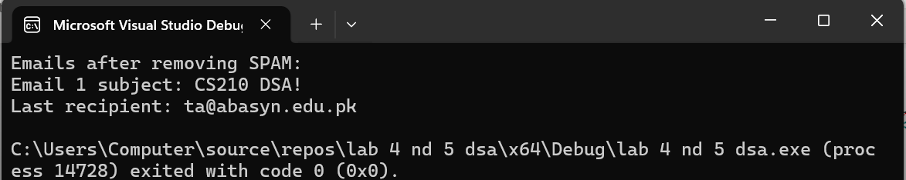
Task 6 [10]
Write a function CountLetters that takes a filename and prints the number of times each letter of the alphabet appears in that file. Because there are 26 numbers to be printed, CountLetters needs to create a Vector. For example, if the file is: Abcd K.. ijk;; cab-Bage fad
CountLetters should print the following:
a: 4 b: 3 c: 2 d: 2 z: 0
When you really print this out, it should be 26 elements long, but we couldn't easily display that on the page. Note that there may be upper case letters, lower case letters, and non-letter characters in the file. All letters should be counted regardless of case (so “Aa” is two a’s), and non-alphabetic characters should be ignored. You should use the following prototype. void CountLetters(string filename);
Code:
#include <iostream>
#include <fstream>
#include <vector>
#include <cctype>
using namespace std;

void CountLetters(string filename)
{
ifstream file(filename);
if (!file)
{
cout << "Cannot open file: " << filename << endl;
return;
}
vector<int> letterCount(26, 0);
char ch;
while (file.get(ch))
{
if (isalpha(ch))
{
ch = tolower(ch);
letterCount[ch - 'a']++;
}
}
for (int i = 0; i < 26; i++)
{
cout << char('a' + i) << ": " << letterCount[i] << endl;
}
file.close();
}
int main()
{
string filename = "sample.txt"; // put your file name here
CountLetters(filename);
return 0;
}
Output:
